SMA-Based Signal Strategy with Backtest
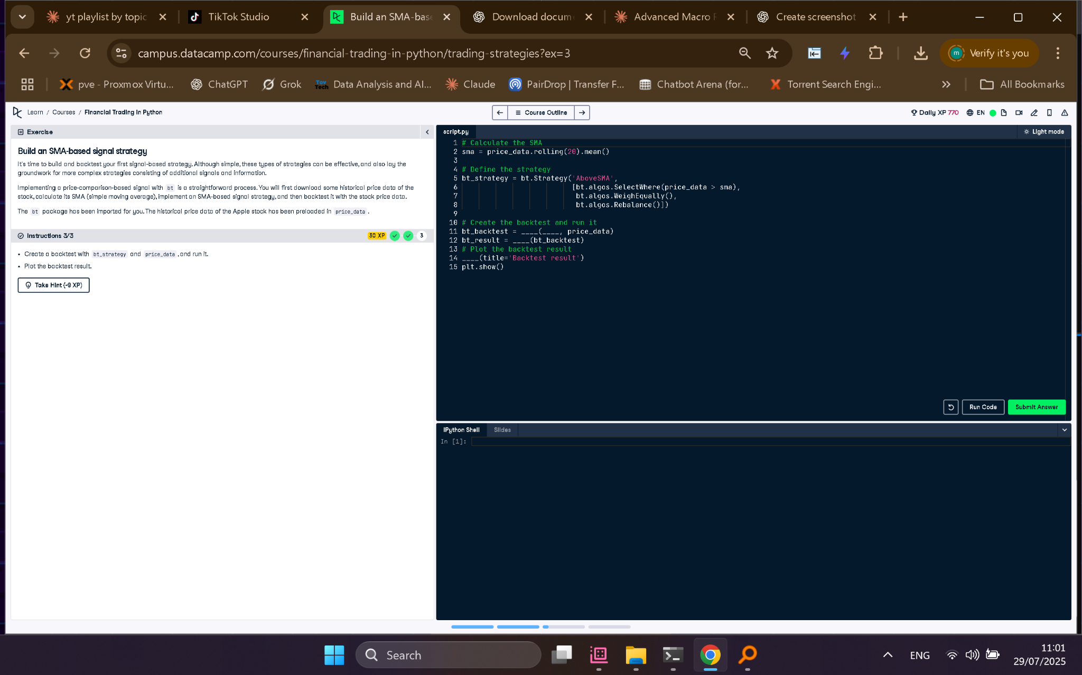

Full Python Answer
# Calculate the SMA
sma = price_data.rolling(20).mean()
# Define the strategy
bt_strategy = bt.Strategy('AboveSMA',
[
bt.algos.SelectWhere(price_data > sma),
bt.algos.WeighEqually(),
bt.algos.Rebalance()
])
# Create the backtest and run it
bt_backtest = bt.Backtest(bt_strategy, price_data)
bt_result = bt.run(bt_backtest)
# Plot the backtest result
bt_result.plot(title='Backtest result')
plt.show()

Explanation in Simple Words
This script builds a trading strategy using a 20-day moving average. If the current price is above the average, the strategy invests. The backtest runs this rule on historical Apple stock data and visualizes the returns. It helps check how profitable the strategy would have been.

